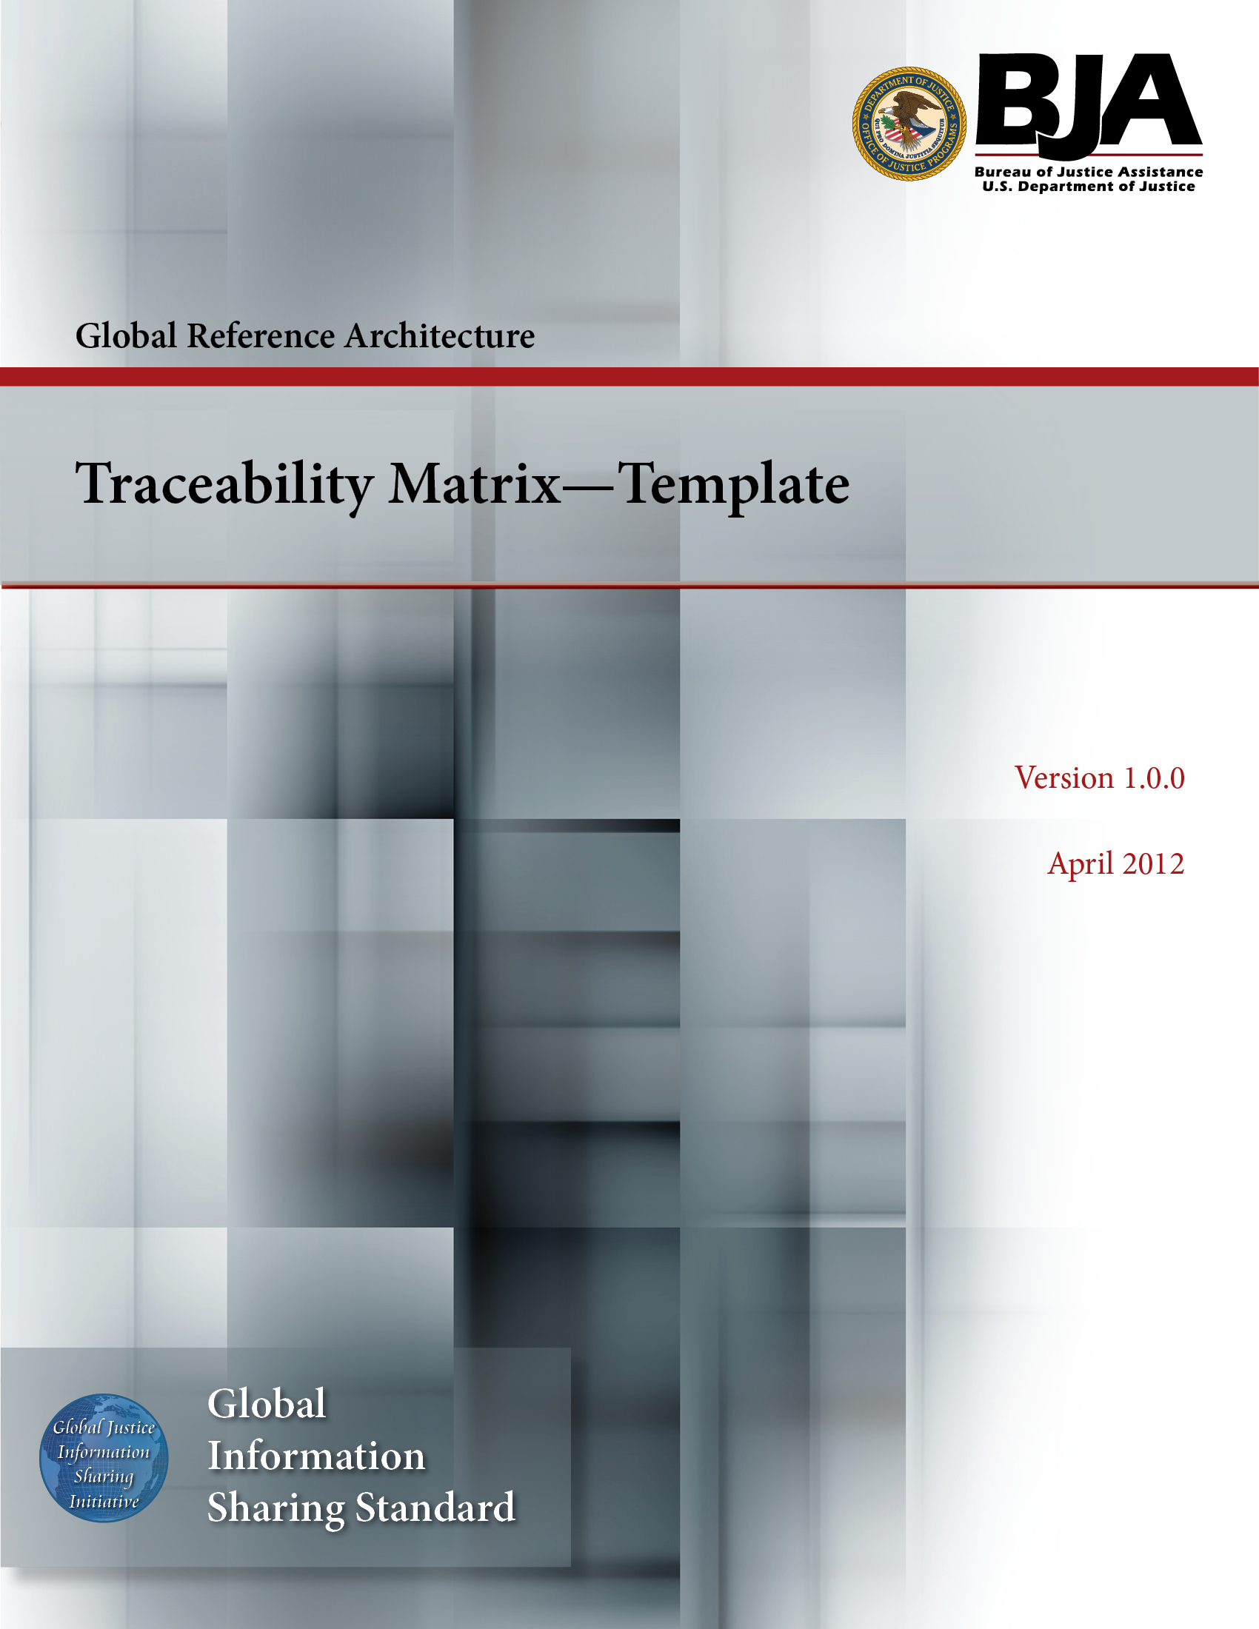


The Global Reference Architecture (GRA)

[Service Name] [Service Abbreviation] [Service Version]

Traceability Matrix (Template)

Version 1.0.0

By [Name of Organization]

[Month Year]

Table of Contents

Document Conventions ii
1. Introduction 1
1.1 Purpose 1
1.2 Scope 1
1.3 Definitions, Acronyms, and Abbreviations 1
1.4 References 1
1.5 Overview 1
2. Requirements Traceability Matrix 2
2.1 Traceability Matrix Structure 2
2.2 Description of Matrix Fields 2
2.3 Requirements Traceability Matrix 4
Appendix A—References 5
Appendix B—Glossary 6
Appendix C—Document History 7

Document Conventions

[Note: The following template is provided for use with the Service Development Process. Text enclosed in square brackets and/or displayed in blue is included to provide guidance to the author and should be deleted before publishing the document.]

<Project Name> Traceability Matrix

Introduction

[The introduction of the Traceability Matrix provides an overview of the entire Traceability Matrix. It includes the purpose, scope, definitions, acronyms, abbreviations, references, and overview of the Traceability Matrix.]

Purpose

The requirements traceability matrix is a table used to trace project life cycle activities and work products to the project requirements. The matrix establishes a thread that traces requirements from identification through implementation.

[This section defines the role or purpose of the Traceability Matrix in the overall project documentation and briefly describes the structure of the document. Specific audiences for the document are identified, with an indication of how they are expected to use the document.]

Scope

[A brief description of what the Traceability Matrix applies to; what is affected or influenced by this document.]

Definitions, Acronyms, and Abbreviations

[This subsection provides the definitions of all terms, acronyms, and abbreviations required to properly interpret the Traceability Matrix. This information may be provided by reference to the project’s Glossary.]

References

[This subsection provides a complete list of all documents referenced elsewhere in the Traceability Matrix. Identify each document by title, report number (if applicable), date, and publishing organization. Specify the sources from which the references can be obtained. This information may be provided by reference to an appendix or to another document.]

Overview

[This subsection describes what the rest of the Traceability Matrix contains and explains how the Traceability Matrix is organized.]

Requirements Traceability Matrix

Traceability Matrix Structure

[This section informs the reader about the structure of the traceability matrix. See example below.]

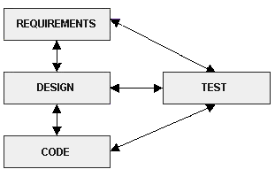

Description of Matrix Fields

[Develop a matrix to trace the requirements from identification of the requirements forward, going through the remainder of the project life cycle stages. Expand the matrix in each stage to show traceability of work products to the requirements and vice versa.]

[Below is an example of a requirement traceability matrix description and the actual matrix layout.

The requirements traceability matrix should contain the following fields:

- A unique identification number containing the general category of the requirement (e.g., SYSADM) and a number assigned in ascending order (e.g., 1.0; 1.1; 1.2)

- The requirement statement

- Requirement source (conference; configuration control board; task assignment, etc.)

- Software requirements specification/functional requirements document identifier

- Design specification identifier

- Program module containing the requirement
- Test specification containing the requirement test

- Test case number(s) where requirement is to be tested (optional)

- Verification of successful testing of requirements

- Modification field. If requirement was changed, eliminated, or replaced, indicate disposition and authority for modification

- Remarks

Requirements Traceability Matrix

[Different projects trace requirements differently. Below is an example of one such matrix.]

Unique Number | Requirement | Source of Requirement | Software Requirements Specification/  Functional Requirement Document | Design Specification | Program  Module | Test  Specification | Test Case(s) | Successful Test Verification | Modification of  Requirement | Remarks
Objective 1:

Appendix A—References

[This section is used to list applicable references.]

[Reference name and description] | [Fully qualified link/path to the reference information]

Appendix B—Glossary

[This section is used to list glossary terms used in the document.]

[Glossary term or acronym] | [Glossary term or acronym description]

Appendix C—Document History

[This section is used to document the history of the service description document.]

Date | Version | Editor | Change
December 11, 2011 | 1.0.0 | James Dyche  Iveta Topalova | Final 1.0.0 revision
December 20, 2011 | 1.0.0 | David Gillespie | Initial edit of 1.0.0 revision
April 2012 | 1.0.0 | Global Standards Council (GSC) | Global Advisory Committee (GAC) approved



